Use this guide to manually adjust repeat transfer credits.

When a student gets transfer credit that allows repeats when typically a course cannot be repeated, follow these steps:

1) Articulate the transfer credit. Validate it and see it’s not correct. You’ll see a “Notes” section appear on a student record to tell you that Workday is taking the best attempt.

EXAMPLE:
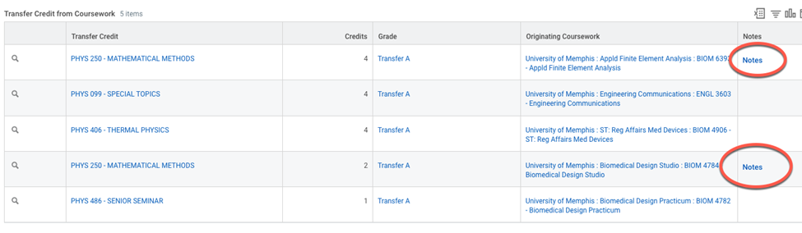

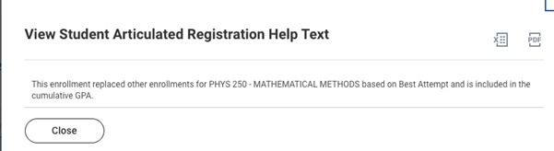

2) Go to Find Course Definition.

3) On the course, use the related action, go to Course Definition, and Edit.

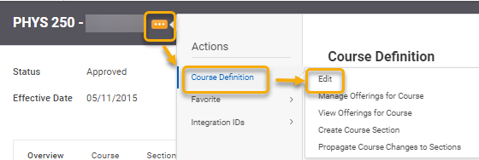

4) Use the current version. Don’t change dates and click OK.

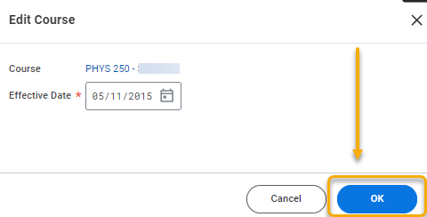

5) Scroll about halfway down to “Repeatable for Additional Credit.” Check the box and change the number of attempts and credits to account for your transfer situation. Scroll to the bottom and click “Submit”.

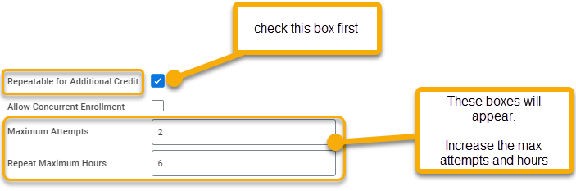

6) Go to the task Assign Student Transfer Credit. Select the student and the school where they got transfer credit that you need to correct.

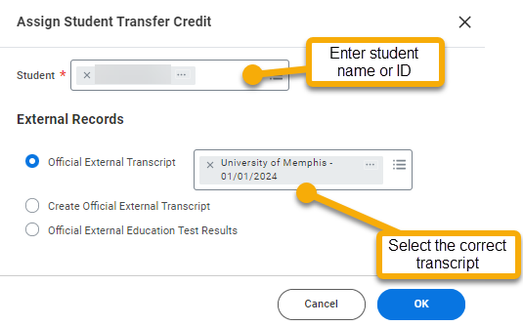

7) Find the courses where the repeat should be allowed. Switch the grade from the current grading scheme (most likely standard) to historical. Select the same grade. You do have to click twice on the grade field to get it to come up as sometimes it pulls the course. Click OK.

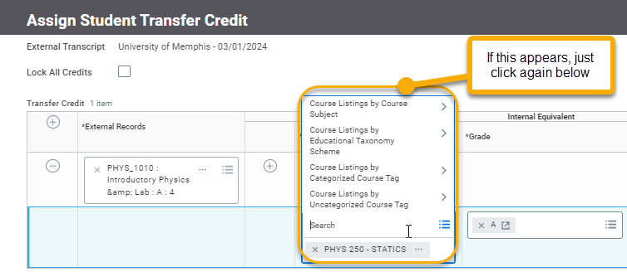

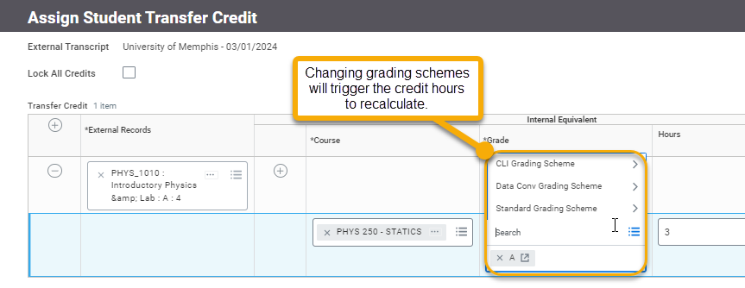

8) Go back to the student’s record in the Academic History. Confirm the credits are correct.

9) Go back to the task Find Course Definitions. Go back into the editing the course on the current version by clicking OK and not changing the date.





10) Go to the “Repeatable for Additional Credit” section. Change the Attempts and Credits back to what it was originally. Then uncheck the box for repeatable. Click Submit.

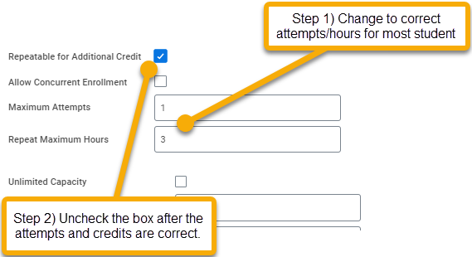

11) Go double-check the student’s record to make sure the academic history is still showing up correctly.

